**Recommendations for Big Mountain Resort**

Objective:

Adjust ticket price according to different facilities offered to optimize its use of facilities either by expanding capital equipment to raise ticket price or by cutting cost to reduce operation cost.

With the objective in mind, here are the trained model for recommendation.

**Scenario 1 – Permanently close down 10 of the least used runs**

As shown in the graphs below,

- closing 1 run makes no difference

- closing 2 and 3 runs reduces support for ticket price and so revenue

- if you close 3 runs, you might as well close 4 to 5 runs as there is no further loss in ticket price

- closing 6 runs or more will lead to a large drop in ticket price

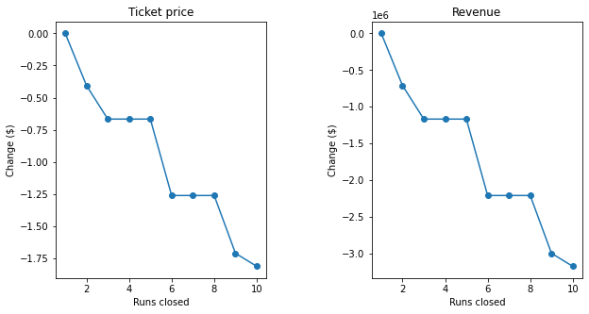

**Scenario 2 – Add a run to a point 150 feet lower to increase the vertical drop, add an additional chair lift to bring skiers back up**

This increases support for ticket price by $1.99 per ticket, contributing to an increase of $3.47M of revenue over the season.

**Scenario 3 – Add 2 acres of snow making coverage on top of scenario 2**

Adding extra facilities on top of scenario 2 also increases ticket price by $1.99 per ticket, making no increment in ticket price and revenue compared to scenario 2.

**Scenario 4 – Increase longest run by 0.2 miles, this will require an additional 4 acres snow making coverage**

This returns no difference in price and revenue because longest run is not an important feature to influence price in the model we choose.

**Current price vs. modeled price**

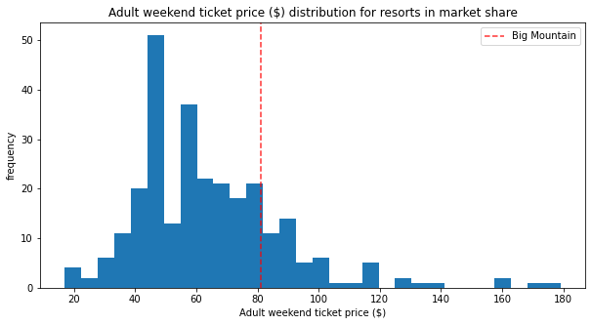

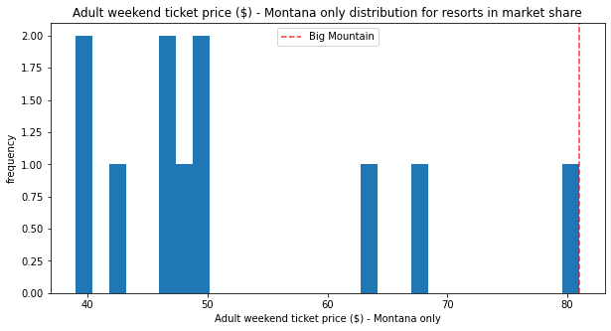

The current adult weekend ticket price of Big Mountain Resort is $81.00, most expensive in Montana and in the top quartile across different states. Despite of the already high price compared to local competitors, our model shows that Big Mountain can further increase its adult weekend price to $95.87, with an uncertainty of $10.39 +/- from $95.87.

Below lists the reasons that justify the suggested price.

**Feature influence**

There are 7 features relatively correlated with ticket price, ordered by their importance.

1. Vertical drop
2. Snow making coverage
3. Total chairs
4. Fast quads
5. Runs
6. Skiable terrain area
7. Trams

Please be noted that skiable terrain area and trams are both negatively correlated with ticket price, meaning these features will be reduced with the goal of increasing the ticket price.

Vertical drop

Increase vertical drop will further increase ticket price although Big Mountain has already been in the top quartile of all resorts.

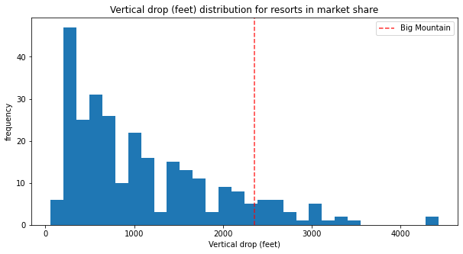

Snow making coverage

Increase snow making coverage will increase ticket price. Skiers value more guaranteed snow, which would cost in terms of snow making equipment, which would drive prices and costs up.

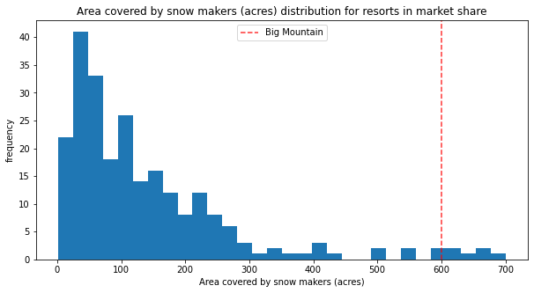

Total number of chairs

Increase total number of chairs will increase ticket price. More chairs will bring more skiers back up.

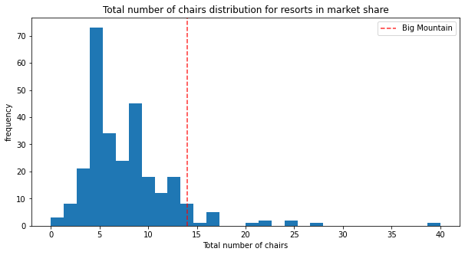

Number of fast quads

Increase number of fast quads will increase ticket price.

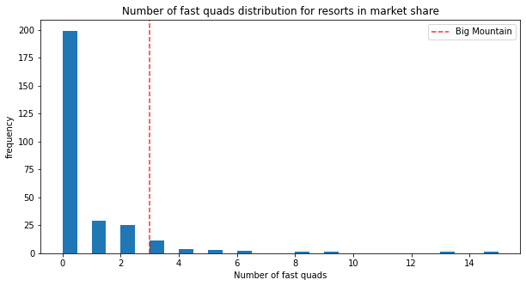

Total number of runs

Increase total number of runs will increase ticket price. This is similar to number of chairs. More runs will allow skiers to ski.

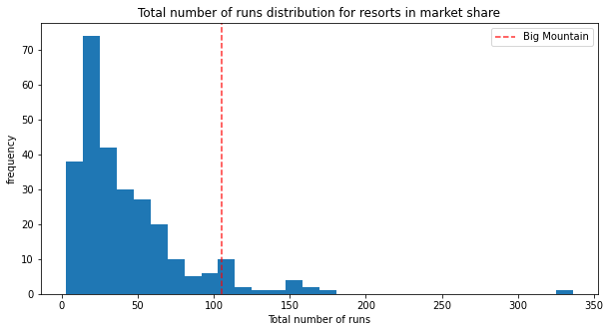

Skiable terrain area

Reduce skiable terrain area will increase ticket price. This may take a bit of grain and salt as the resorts charging expensive tickets may not have the largest skiable area. It may be due to larger resorts can host more visitors at any time so they can charge less per ticket, or any other reasons.

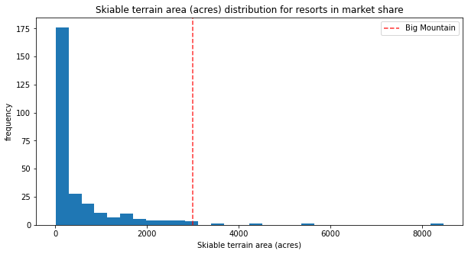

Number of trams

Reduce number of trams will increase ticket price. But no adjustment is needed as Big Mountain has none.

